**Final Project Report**

**Group Members:** Christopher Tran, Filip Todorovic

**Project:** Online Book Store (PlaceHolderBookstore)

**Technology Used:** JSP, Apache Tomcat, SQL Database

**Tools Used:** SQL Workbench, IntelliJ IDE

**Overview**

**Users**: Anyone who would like to purchase books online at a reasonable price. The Website offers users to create their profile, purchase books, rate books, modify their cart, view top selling books, browse books, and search for specific books.

**Administrators**: Admins will be able to modify the stock of each book, manage invoices as orders are processed, and get a weekly and monthly sales report.

**Scenarios**

**Users:**

1. **A user wants to see what new books came in to the store.** The user goes to the home page and sees a list of the newest books that have arrived. The user clicks on a book and sees a description of the book. They press the purchase button and finalize their purchase of the new book.
2. **A user wants to create an account.** The user goes to the home page and clicks Register. They are prompted to fill out information such as email and password. Once all fields are entered, the user clicks “Sign Up” and their account is created and they are logged into the site, reverting back to the home page.
3. **A user wants to browse top selling books.** From any page, a user can click “Top Sellers” and a list of the top selling books is generated in the middle. The user can then click on a book to go to the books description page.
4. **A user wants to browse books on the site.** From any page, a user can click “Browse Books” and a list of all books, ordered by genre.
5. **A user wants to search for a specific book.** From any page, a user can enter a full search or partial search (minimum 2 characters long) into the Search box on the right side. A list of all books containing the search entry will be listed, with links to each book’s page.
6. **A user wants to continue shopping after adding a book to cart.** A user can either continue shopping or checkout once they click the “Purchase” button from a book’s webpage. If a user continues shopping, they can add more books in the same way, as well as click the “Show Cart” link from any page to display the current books that are in the user’s cart.
7. **A user wants to modify their shopping cart.** A user can click the “Show Cart” link and view the items they wish to purchase. From there, they can modify the quantity of the book. If they choose ‘0’ quantity, the item will be removed from the cart. Similarly, a user can click the red circle on the right of the item to completely remove it from the cart.

**Administrators:**

1. **An admin wants to modify the inventory of books.** Under the Admin page, an admin can click the “Modify Inventory” button and be taken to a list of all books where they can increase or decrease the inventory size of each book. Also, at the bottom of the page, admins can add a new book by entering all the necessary information along with a jpeg file which will be displayed as the picture of the book.
2. **An admin wants to view the latest sales reports.** Under the Admin page, an admin can click the “Display Reports” button to view a table of sales and book count from the current week, previous week, current month, previous month, as well as the difference in sales between the previous time slot.
3. **An admin wants to review and process invoices.** Under the Admin page, an admin can click the “Process Invoices” button which will generate a list of all unprocessed invoices. The admin can then select a specific invoice and process it once they have properly prepared the book(s) for delivery.
4. **Admin wants to add book to the store inventory.** Under the admin page and inventory section, an admin can enter information needed to add more books to the database and they will instantly be available
5. **Admin wants to view limited marketing data.** Under the admin page and within the Market Data page, this will list all categories and the number of books a user has purchased. This is not limited and will show all data and not just top buyers.

**Assumptions**

* Not yet fully public so security and protection against attacks aren’t a focus
* All users understand that their passwords are not secure.
* Admins understand that they all have the same access rights.
* Admins will be responsible for checking that users entered a valid shipping address.
* Users will not be requesting returns for purchases.
* Users will not want to cancel an order before it has been shipped.
* All users are fluent in English.
* All users use the US Dollar currency.

**Data Description**

**Invoice**: Contains identifying information on the user and total of transaction

**Lineitem**: Individual transaction items in an invoice with product identifier and quantity

**Product**: Holds all information pertaining to a single book, such as description, ISBN#, author, etc.

**Ratings**: Holds the rating details for each rating entry. Includes the user email and the books ISBN for relation. UserID is not used in the case that a User is removed, their rating will still remain in the system.

**User**: Holds all of the information pertaining to a single user, including name, address, email, and sign-in dates.

**Graphical Schema**

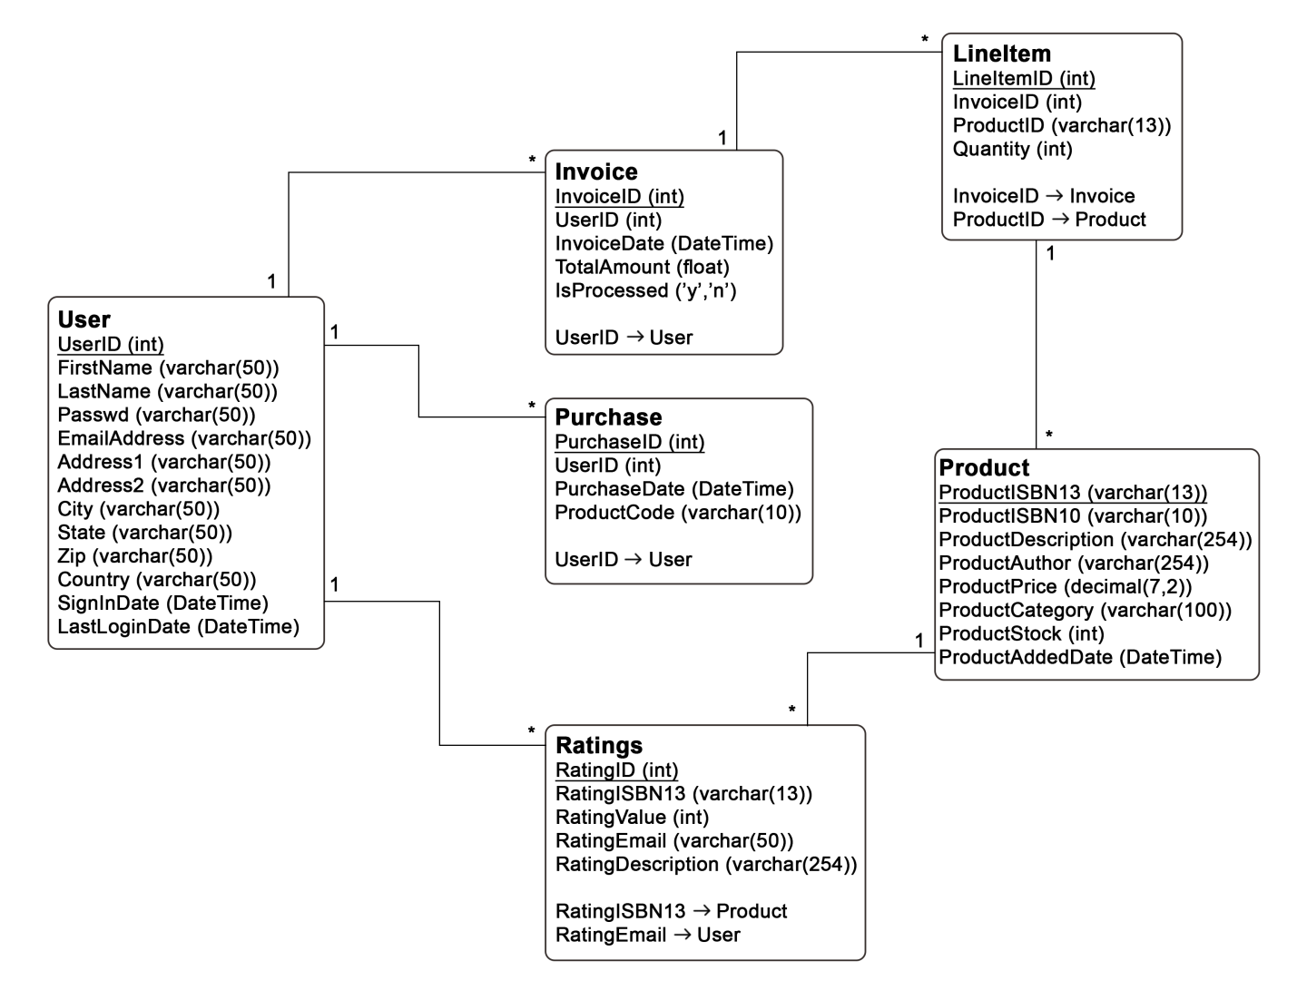

**Example Screenshots**

|  |  |
| --- | --- |
| Home Page | Browse Books |
| C:\Users\Filip\AppData\Local\Microsoft\Windows\INetCache\Content.Word\Homepage BS.PNG | C:\Users\Filip\AppData\Local\Microsoft\Windows\INetCache\Content.Word\Browse books BS.PNG |

|  |  |
| --- | --- |
| Book Details | Inventory Modification |
| C:\Users\Filip\AppData\Local\Microsoft\Windows\INetCache\Content.Word\Book BS.PNG | C:\Users\Filip\AppData\Local\Microsoft\Windows\INetCache\Content.Word\Inventory BS.PNG |

|  |  |
| --- | --- |
| Sales Reports | Cart Page |
| C:\Users\Filip\AppData\Local\Microsoft\Windows\INetCache\Content.Word\Reports BS.PNG | C:\Users\Filip\AppData\Local\Microsoft\Windows\INetCache\Content.Word\Cart BS.PNG |

**System Limitations and Future Improvements**

Limitations:

* Credit Card transaction functionality not implemented.
* Only one type of admin can be created with access to all admin privileges.
* Invoices cannot be processed at this time.

Future Improvements:

* Allow for admins to specify a date range for sales data
* User and session encryption
* Separate sections for billing and site administration
* Limit scope of data showed on the website so when database gets larger, the entire database isn’t parsed.